LAB # 11
Introduction to Test Suite
OBJECTIVE: Grouping the multiple JUnit test cases and constructing a Test Suite program. Test suite: Test suite is used to bundle a few unit test cases and run them together. In JUnit, both @RunWith and @Suite annotations are used to run the suite tests.
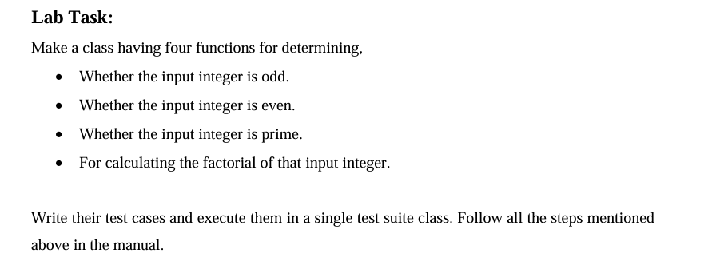
CODE
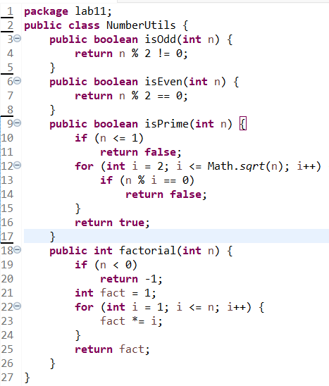

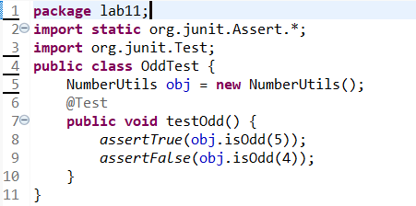
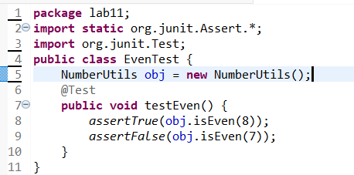
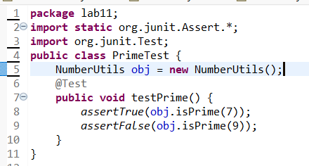
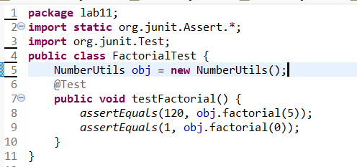
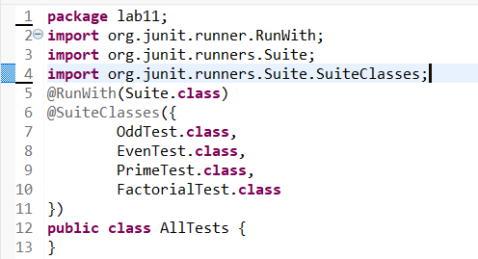

OUTPUT
